**Instructions**

1. Navigate to <https://gitlab.com/mpatek/cs506-multitask-overlay/tree/Iteration2> (otherwise from the main project, it is the “Iteration2” branch)
2. Click the download button next to “Web IDE” and select download as zip folder

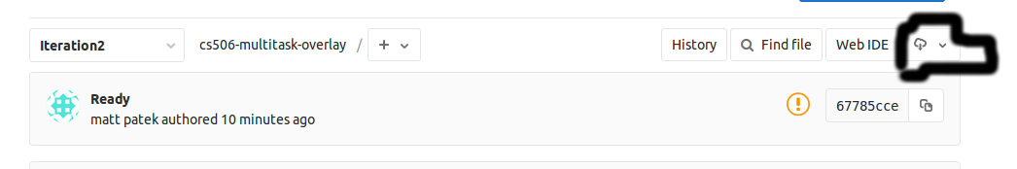

1. Extract the folder
2. Navigate to the folder and run “npm install”
3. To test the main app, change to the “App” directory
   1. Run “npm install” (yes it needs to be run here too)
   2. Run “npm start”, this will load the app
   3. If you want to run tests, use “npm run unit” to run unit tests and “npm run int” to run integration tests
4. Optional:To test overlay ***WINDOWS ONLY***
   1. Go into the /App/binding.gyp and uncomment the line "../Background/main.c"
   2. Next in /App/package.json switch the script from “main.js” to “main2.js”
   3. Run “npm install” (yes it needs to be run here too)
   4. Run “npm run bunny”
   5. Once you minimize the main app a widget will appear in the top right computer, to toggle interaction with the widget type “ALT+X”
   6. To minimize the widget type “CTRL+1”
   7. To show the widget type “CTRL+B”
   8. To Exit, in the terminal type”CTRL+C” Twice.